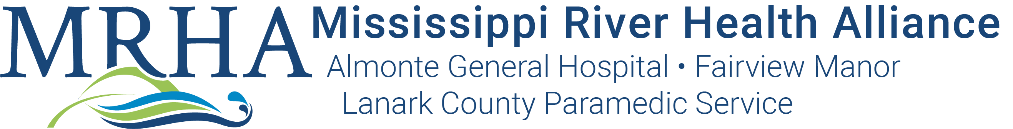

Personal Support Workers

Fairview Manor
Full-time, Part-time & Casual

Almonte General Hospital and Carleton Place & District Memorial Hospital created the Mississippi River Health Alliance (MRHA) in 2016 to formalize their commitment to work together to improve each patient and resident’s overall health care experience through a strong, coordinated system of care. An integrated Senior Team leads the two Hospitals, as well as Fairview Manor and Lanark County Paramedic Service which are operating divisions of AGH. Over 600 caring staff, physicians and midwives provide excellent primary, acute and long-term care to citizens of Lanark County, West Ottawa and Renfrew County.

We are currently seeking Personal Support Workers to join our amazing team.
Competencies and Personal Attributes:
- Commitment to excellence, quality, and patient/resident safety.
- Demonstrated caring and empathetic attitude.
- Ability to meet all demands of the job, both physical and cognitive
- Ability to work cooperatively and respectfully within a team environment.
- Ability to receive direction and understand and follow policies and procedures.
- Ability to work in a manner that is in compliance with patient/resident and employee safety practices, policies and procedures of the organization.
- Ability to contribute to a work environment that is conducive to the organizations Workplace Violence and Harassment policy.

Mandatory Requirements:

Fairview Manor:
- Successful completion of a recognized Personal Support Worker program, including formal certification by a recognized Community College
- Previous experience in a Complex Continuing Care or Long Term Care Setting would be preferred
- Current CPR

Employee Benefits:
- Competitive Compensation Packages
- Hospital of Ontario Pension Plan (HOOPP)
- Employee & Family Assistance Programs

Qualified candidates are invited to submit their resumes to:
Angela McLean, Integrated Human Resources Manager
Email: careers@agh-fvm.com

We thank all candidates who apply; only those selected for an interview will be contacted.

We are committed to inclusive and accessible employment practices - If you require accommodation throughout any part of the recruitment process, please contact Human Resources to let us know how we may assist you.

Please note that according to the MRHA Vaccination Policies, all applicants must be fully vaccinated unless they can provide the proof of a valid medical contraindication or exemption on the basis of protected grounds under the Ontario Human Rights Code in order to be considered for any staff or volunteer opportunities. Upon hiring, applicants must provide the proof of either government issued documentation proving they have been fully vaccinated, or present supporting documentation of a valid medical contraindication or exemption under Ontario Human Rights Code.

