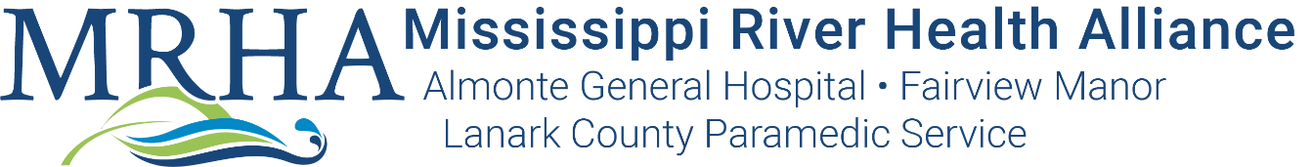

REGISTERED PRACTICAL NURSE – PERMANENT FULL-TIME
OPERATING ROOM

Almonte General Hospital and Carleton Place & District Memorial Hospital created the Mississippi River Health Alliance (MRHA) in 2016 to formalize their commitment to work together to improve each patient and resident’s overall health care experience through a strong, coordinated system of care. An integrated Senior Team leads the two Hospitals, as well as Fairview Manor and Lanark County Paramedic Service which are operating divisions of AGH. Over 600 caring staff, physicians and midwives provide excellent primary, acute and long-term care to citizens of Lanark County, West Ottawa and Renfrew County.

Competencies and Personal Attributes

- Commitment to excellence, quality, and patient/resident safety.
- Demonstrated caring and empathetic attitude.
- Ability to meet all demands of the job, both physical and cognitive
- Ability to work cooperatively and respectfully within a team environment.
- Ability to receive direction and understand and follow policies and procedures.
- Ability to work in a manner that is in compliance with patient/resident and employee safety practices, policies and procedures of the organization.
- Ability to contribute to a work environment that is conducive to the organizations Workplace Violence and Harassment policy.

Mandatory Requirements
- Registered with the College of Nurses of Ontario (CNO)
- Two (2) years’ recent (within the last year) experience working in OR setting
- Completion of a recognized Perioperative Program
- Must be able to do On Call shifts as required (reside within 30 minute)

Qualified candidates are invited to submit their resumes to:
Angela McLean, Integrated Human Resources Manager, Recruitment amclean@agh-fvm.com

